



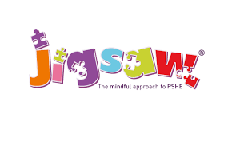




GCSE results day support
Job sector insights assembly
‘Learning Effectively’ university presentation

Apprenticeship
Results day support
CV and job application workshop
One-to-One guidance
‘Applying through clearing’ presentation
University application support
UCAS Personal Statement writing workshop
YEAR
13
UCAS HE Fair Trip
5 Day Work shadowing placement
One-to-one guidance
Visit to a local university
Apprenticeship fair trip
Budgeting workshop
Student finance presentation
‘Introduction to UCAS’ presentation
YEAR
12
‘Dreams and Goals’ PSHE unit

Post 16 application support
Transition event to a local college
Sixth Form open evening
6th Form, College and Apprenticeship assemblies
One-to-One Guidance
5 Day Work shadowing placement

YEAR
11

‘What are apprenticeships?’ assembly
Job sector insights assembly

‘Dreams and Goals’ PSHE unit

Next steps assembly

YEAR
10
Local magistrates workshop
Job sector insights assembly

3 Day Work shadowing placement

Choosing your GCSE options support
‘Why go to uni?’ presentation
‘Dreams and Goals’ PSHE unit

Next steps assembly

YEAR
9
STEM Challenge

3 Day Work shadowing placement

Job sector insights assembly

‘Dreams and Goals’ PSHE unit

Next steps assembly

YEAR
8
‘Understanding HE’ presentation
STEM Challenge
3 Day Work shadowing placement
Job sector insights assembly
‘Dreams and Goals’ PSHE unit
Transition Day – meet our staff
Next steps assembly
Sign up to Morrisby careers platform
YEAR
7
Scholarship
Supported Internship
College
Traineeship
University
Employment
PRIMARY
SCHOOL

