


Aylesford School Pupil Premium strategy statement

This statement details our school’s use of pupil premium (and recovery premium for the 2021 to 2022 academic year) funding to help improve the attainment of our disadvantaged pupils.
It outlines our pupil premium strategy, how we intend to spend the funding in this academic year and the effect that last year’s spending of pupil premium had within our school.

School overview

Detail | Data
School name | Aylesford School
Number of pupils in school | 928
Proportion (%) of pupil premium eligible pupils | 25.35%
Academic year/years that our current pupil premium strategy plan covers (3 year plans are recommended) | 2025 –2027
Date this statement was published
Date on which it will be reviewed | July 2026
Statement authorised by
Pupil Premium Lead | Byron Walker / Michelle Johnston
Governor / Trustee lead | Joanne Coveney

Funding overview

Detail | Amount
Pupil premium funding allocation this academic year | £230,588
Recovery premium funding allocation this academic year | £0
Pupil premium funding carried forward from previous years (enter £0 if not applicable) | £0
Pupil Premium funding that is used to cover PFI Chartwell Free School Meal costs.  We are charged £3.34 per free school meal and were charged for 23,376 meals | £78,075
Total budget for this academic year  If your school is an academy in a trust that pools this funding, state the amount available to your school this academic year | £152,513

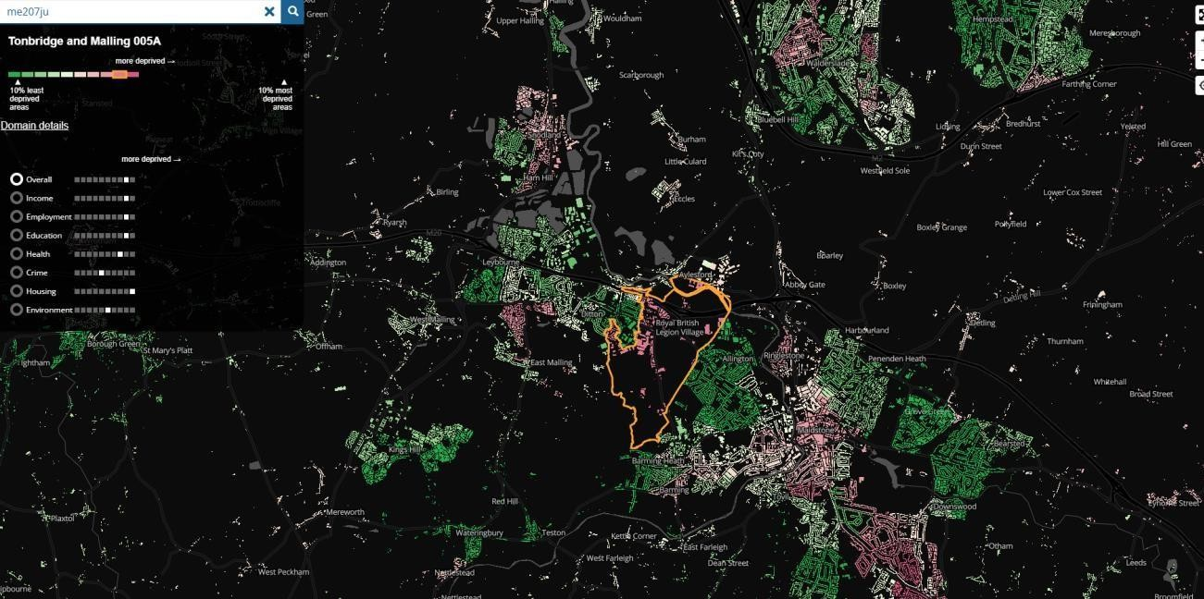
Part A: Pupil premium strategy plan

Aylesford School is a non-selective secondary school located in the borough of Tonbridge and Malling close to the town of Maidstone. Currently, 25.35% of students are eligible for Pupil Premium funding which is slightly higher than the local average (24.5%), and in line with the national average. The catchment area for the school contains areas of great deprivation, with a large proportion of students from these areas opting to attend Aylesford School.

Statement of Intent

Objective
At Aylesford School, our objective is to ensure that every pupil, regardless of background, has the opportunity to achieve and succeed. We are committed to closing attainment gaps, securing strong progress across the curriculum, and ensuring that disadvantaged pupils are fully prepared for their next stage of education, employment, or training. Alongside academic success, we place equal importance on developing resilience, confidence, and independence, so that pupils are equipped to overcome barriers, engage fully in school life and realise their potential.

Key principles
Our strategy is built on the principle that, If we get it right for our most disadvantaged pupils, we improve outcomes for all.

There are key strategies and methodologies that schools have employed to close the attainment gap and improve the social mobility of disadvantaged students.

Strategy Focus
Our Pupil Premium strategy is built around the following key approaches:
:
- Closing attainment gaps through consistently high-quality teaching and a well-sequenced, ambitious curriculum, underpinned by evidence-informed practice and a whole-school commitment to meeting the needs of disadvantaged pupils in every classroom.
- Using precise assessment, robust data analysis, and regular progress monitoring to identify barriers early, ensuring that underachievement is addressed swiftly through targeted and responsive intervention.
- Improving attendance and reducing persistent absence through proactive monitoring, early intervention, and strong partnership with parents and carers, recognising that time in school is fundamental to success.
- Providing targeted academic support that is closely aligned to the curriculum, enabling pupils to address gaps in knowledge, develop confidence, and make sustained progress over time.
- Promoting positive behaviour, engagement, and inclusion through clear expectations, consistent routines, and effective pastoral support, ensuring all pupils are ready to learn and able to succeed.
- Developing aspiration, cultural capital, and personal development through a wide range of enrichment opportunities and experiences, ensuring that disadvantaged pupils are fully prepared for their next stage in education, employment, or training.
- Ensuring strong staff ownership of the Pupil Premium strategy, with all staff understanding who disadvantaged pupils are, using evidence-informed strategies in their teaching, and consistently promoting high expectations and positive outcomes.

How does our Pupil Premium strategy work towards achieving these objectives?
At Aylesford School, significant work has been undertaken to ensure that disadvantaged pupils are well supported both academically and pastorally. We recognise that, while progress has been made, continued refinement is required to ensure consistently strong outcomes. Our strategy is designed to address identified barriers through a combination of high-quality teaching, targeted academic support, strong pastoral systems, and equitable access to wider opportunities.

Key actions include:
- A strong focus on quality first teaching, where all staff are expected to know their disadvantaged pupils and adapt their teaching accordingly. This includes careful use of seating plans, prioritised feedback, and adaptive strategies to ensure pupils can access learning and make progress within lessons.
- Ensuring equitable access to learning resources and opportunities, including the provision of revision materials, ICT equipment, and financial support for enrichment activities. This removes barriers to participation and ensures that disadvantaged pupils can fully engage in both academic and wider school life.
- Targeted academic support and intervention, where disadvantaged pupils are prioritised for small group work, tuition, and additional learning opportunities, including weekend and after-school sessions led by subject specialists. These interventions are used to address gaps in knowledge and improve attainment.
- A structured approach to independent learning, including access to online platforms such as reading resources and the provision of quiet study spaces within school. This supports pupils who may not have access to suitable learning environments at home.
- Effective use of support staff and pastoral systems, ensuring that disadvantaged pupils receive both academic and wellbeing support. Staff are deployed strategically to support learning, engagement, and wider needs.
- A commitment to inclusive practice and staff development, including training to support students with additional needs and to ensure that all staff are equipped to work effectively with disadvantaged and hard-to-reach pupils.
- Strong emphasis on engagement and participation, ensuring that disadvantaged pupils have equal access to extra-curricular activities and enrichment opportunities, helping to build cultural capital, confidence, and aspiration.

Challenges
This details the key challenges to achievement that we have identified among our disadvantaged pupils.

Challenge number | Detail of challenge
Internal
1 | Consistency of Teaching and Curriculum Implementation  While there are strong examples of effective practice, there remains some variability in how consistently high-quality teaching and curriculum delivery are implemented, particularly at Key Stage 3. This can lead to gaps in foundational knowledge, which then impact pupils’ readiness for KS4 and their ability to achieve strong outcomes.
2 | Independent Learning and Metacognition  Disadvantaged pupils are more likely to require additional support in developing independent learning habits, including organisation, revision strategies, and self-regulation. Without explicit teaching of these skills, pupils may struggle to retain knowledge, prepare effectively for assessments, and make sustained progress over time.
3 | Aspiration and Cultural Capital  Some disadvantaged pupils have limited exposure to experiences beyond their immediate environment, including careers pathways, higher education, and enrichment opportunities. This can result in lower aspirations and reduced motivation, impacting engagement in learning and long-term outcomes.
4 | Literacy and Knowledge Gaps  A significant proportion of disadvantaged pupils enter the school with lower levels of literacy, including reading comprehension and vocabulary. This limits their ability to fully access the curriculum, particularly in subjects requiring extended reading and writing. Without targeted support, these gaps can widen over time, impacting progress across all subjects and limiting attainment at KS4.
External
5 | Attendance  Attendance for disadvantaged pupils, while improving, remains below that of their non-disadvantaged peers. Persistent absence continues to affect a small but significant group of pupils, reducing their time in lessons and limiting their ability to keep up with curriculum content. Improving attendance remains a key priority to ensure consistent access to learning.
6 | Parental Engagement  Engagement with parents and carers of disadvantaged pupils can be variable. Lower levels of engagement can impact attendance, behaviour, and support for learning outside of school. Strengthening home-school communication and partnership is key to improving outcomes.
7 | SEMH and Wellbeing  Some disadvantaged pupils experience higher levels of social, emotional, and mental health needs. These can affect behaviour, attendance, and engagement in learning.

Intended outcomes
This explains the outcomes we are aiming for by the end of our current strategy plan, and how we will measure whether they have been achieved.

Intended outcome | Success criteria
Gaps continue to narrow in all subjects term by term across the year | Gaps between disadvantaged and non-disadvantaged pupils will continue to narrow across all subjects over time. This will be evidenced through termly monitoring showing that Pupil Premium pupils are on track to meet their end-of-year targets, with comparisons demonstrating that they are increasingly achieving outcomes in line with their peers.
Levels of attainment for Mathematics and English improve | Attainment in English and Mathematics for disadvantaged pupils will improve year on year. This will be evidenced by an increase in the proportion of pupils achieving Grade 4+ and 5+, alongside a growing number achieving higher grades (7+) in both subjects, reflecting stronger progress and deeper understanding.
Students have clear ideas about post-16 study and understand the subject requirements for their post-16 goals | Disadvantaged pupils will be well prepared for their next stage of education, with clear understanding of post-16 pathways and subject requirements. This will be evidenced through all pupils receiving targeted guidance, including one-to-one meetings, mentoring, or interviews, resulting in clear, informed pathways and aspirational goals.
Increased attendance rates for pupils eligible for PP | Attendance for pupils eligible for Pupil Premium will improve so that it is increasingly in line with that of their peers. This will be evidenced by a reduction in persistent absence to below 20% and a sustained improvement in overall attendance rates for disadvantaged pupils, narrowing the gap with non-disadvantaged pupils over time.
Pupil Premium students to engage with and attend extra-curricular clubs and activities, including trips on a local, national and international level | Disadvantaged pupils will actively engage in extra-curricular activities and enrichment opportunities at local, national, and international levels. This will be evidenced through increased participation rates, removal of financial barriers, and the development of a whole-school tracking system that records and evidences engagement and provision for Pupil Premium pupils.

Activity in this academic year
This details how we intend to spend our pupil premium (and recovery premium funding)
this academic year to address the challenges listed above.Teaching (for example, CPD, recruitment and retention)
Budgeted cost: £ 100,000
Activity | Evidence that supports this approach | Challenge number(s) addressed
Gaps continue to narrow in all subjects term by term across the year.  Study entertainment sessions targeted at underachieving PP students in years 10  /11 to monitor their attainment, effort and attendance, offer incentives to encourage them to raise these.  First wave teaching to consider strategies for PP and action planning for student groups.  PP students first approach to teaching and learning.  Moderation of assessments for PP students (in line with non-pp) and book scrutiny targeted at PP students to check progress is in line with peers.  Increase in metacognition and self- regulation teaching.  https://educationendowmentfounda | A clear focus this academic year showed measurable impact on students’ attainment, in house initiatives with more stakeholders and a tighter focus on underachieving students. Teachers and leaders continue to build on the progress and attainment of students throughout the academic years.  EEF: Oral language interventions aim to support learners’ articulation of ideas and spoken expression. All pupils appear to benefit from oral language interventions, but some studies show slightly larger effects for pupils disadvantaged backgrounds (up to six months' additional progress).  EEF: Metacognition and self-regulation ap- proaches have consistently high levels of im- pact, with pupils making an average of seven months’ additional progress. These strategies are usually more effective when taught in col- laborative groups so that | 1,2,3,4

tion.org.uk/evidence- summaries/teaching-learning- toolkit/  In lessons tasks to be explained and understanding checked of PP students first | learners can support each other and make their thinking explicit through discussion.
Character strengths to be awarded and monitored.

SLT and Middle leaders to read Sutton Trust research, KCC toolkit and Endowment Trust toolkit, Ofsted research to gain better understanding of students and strategies that are low in time and cost but have high impact – to be summarised and linked to Aylesford Context.

Find strategies within lessons to build PP students Courage, Confidence and Character first.
Levels of attainment for Mathematics and English improve  High quality teaching in the classroom with teachers having an awareness of the impact of Pupil premium and strategies to address the barriers this can cause  Students provided opportunities to attend revision, masterclasses and access | PP students underachieve nationally at GCSE in English and Maths  Sutton Trust research states that the most important use of funding is to raise attainment for PP students to allow them the qualifications required after education  Sutton Trust, 2011 report on improving the impact of teachers on pupil achievement in | 1,2,3,4,7

support from Specialist English and Maths teachers during and after school hours  KS4 Students able to benefit from theatre companies to support GCSE English texts regardless of their financial background  School Led Tutoring focused on disadvantaged students to try and close gaps in English Language  Attainment Data is monitored by Progress Leaders and the Head of English and Maths so they can intervene putting strategies into place for students falling behind. | the UK revealed that the effects of high- quality teaching are especially significant for pupils from disadvantaged backgrounds – equivalent to 1.5 years’ worth of learning  EEF - interventions may well be one part of an effective Pupil Premium strategy, they are likely to be most effective when deployed alongside efforts to improve whole-class teaching, and attend to wider challenges to learning, such as attendance and behaviour  Evidence shows that disadvantaged pupils have been disproportionately impacted by the pandemic. Activity to support those pupils to recover missed learning is an appropriate use of pupil premium funding
Financial support to ensure inclusion. Students supported with the purchase of study material where required to allow  them to access revision and homework  Support can be requested for educational trips and opportunities to ensure students are not disadvantaged | Sutton Trust research (2015) supports the use  of Pupil Premium for funding trips and visits and states that this has allowed visits to go | 1,3,4,5,6,7

Students attend additional tutoring sessions for English and Maths.
All staff to know which students are Pupil Premium and ensure that they use school strategies outlined in policy to improve attainment and engagement of students  Staff to highlight PP students on their seating plans and annotate with bespoke strategies and information  PP student photographs circulated with all staff to encourage recognition  Progress Leaders to discuss pupil premium student in briefings to raise awareness and  improve engagement of strategies with student | EEF – 10 top tips for school leaders and governing boards  Know your school’s attainment gaps. Find out which groups of pupils in your school the data suggest need particular support. Ask your school for its gap data from Analyse School Performance (ASP), formerly RAISEonline, used by Ofsted inspectors. Check your school has an action plan to improve overall attainment while also closing its gaps – and make sure the governing board is monitoring progress. | 1,5,6

Targeted academic support (for example, tutoring, one-to-one support structured interventions)
Budgeted cost: £ 50,000

Activity | Evidence that supports this approach | Challenge number(s) addressed
Students have clear ideas about post-16 study and understand the subject requirements for their post-16 goals | Stem learning: Careers talks and lessons, including outside speakers, have been seen to indicate a long-lasting employment  impact, reinforcing the importance of careers awareness in schools. | 2,3,6,7
To improve aspirations of PP students by providing specific and planned opportunities  to engage with real life experiences that enhance careers and education aspiration  Careers to continue to prioritise working with disadvantaged students and ensuring they have destinations before the end of their study at GCSE– 1:1 meeting to be arranged with all PP students to ensure a career plan  Assemblies and guidance on careers and further education to continue, outside agency used to motivate and encourage students and raise aspirations.  Continue to provide opportunities for all students (and therefore PP students) including careers fairs, careers | The research concludes that being taught about career opportunities in school, as well as meeting employers, had a “meaningful and statistically significant impact on later  earnings”.  Careers education works best when it is personalised and targeted to individuals’ needs from an early age. This, together with school-mediated employer engagement alongside independent and impartial career guidance, is key to supporting young people’s transitions into education, training, and employment.

interviews, work experience and shadowing.

Visits arranged to colleges and universities to raise aspirations for students and allow them to understand post 16 requirements.

Activity | Evidence that supports this approach | Challenge number(s) addressed
Students have clear ideas about post-16 study and understand the subject requirements for their post-16 goals | Stem learning: Careers talks and lessons, including outside speakers, have been seen to indicate a long-lasting employment impact, reinforcing the importance of careers awareness in schools. | 2,3,6,7
To improve aspirations of PP students by providing specific and planned opportunities  to engage with real life experiences that enhance careers and education aspiration  Careers to continue to prioritise working with disadvantaged students and ensuring they have destinations before the end of their study at GCSE– 1:1 meeting to be arranged with all PP students to ensure a career plan  Assemblies and guidance on careers and further education to continue,  outside agency used to motivate and encourage students and raise | The research concludes that being taught about career opportunities in school, as well as meeting employers, had a “meaningful and statistically significant impact on later  earnings”.  Careers education works best when it is personalised and targeted to individuals’ needs from an early age. This, together with school-mediated employer engagement alongside independent and impartial career guidance, is key to supporting young people’s transitions into education, training, and employment.

aspirations.
Continue to provide opportunities for all students (and therefore PP students) including careers fairs, careers interviews, work experience and shadowing.

Visits arranged to colleges and universities
to raise aspirations for students and allow them to understand post 16 requirements.
All PP students able to access online learning during periods of lockdown and remote learning  To ensure that there is equilibrium between students of varying socio- economic backgrounds  Ensure all students have access to correct ICT equipment and internet access to prevent students being unable to access high quality remote teaching and homework. | The Right to Education and ICT during COVID 19: An International Perspective (Luis Miguel Lázaro Lorente, Ana Ancheta Arrabal and Cristina Pulido- Montes, 2020)  Students with access to ICT equipment can engage in online learning practices  Students without adequate ICT support will fall behind those with access, creating a gap in attainment and progress upon return to formal education | 1,4,5,6
Accelerated progress for KS4 Pupil Premium students adversely affected by lockdown and periods of remote learning  Targeted interventions that took place outside of regular school hours, including sessions conducted during half-term breaks and holidays. | EEF - the evidence indicates that small group and one to one interventions can be a powerful tool for supporting these pupils when they are used carefully. | 1,4,5

Trackers to ensure that correct students were targeted based on evidence and assessment data.
Students to be encouraged and prompted to come to revision sessions – financial complications to be dealt with on an individual basis to prevent barriers
Revision material to be provided for all PP students

Wider strategies (for example, related to attendance, behaviour, wellbeing)
Budgeted cost: £ 3,000

Activity | Evidence that supports this approach | Challenge number(s) addressed
Engagement, attendance, and attitudes improve to allow students to achieve greater success at school  Increased attendance rates for pupils eligible for PP.  First calling in the mornings for PP students to allow parental contact and encourage increased attendance  Trips organised to interest and motivate students to attend school  Focus on attendance and attitudes towards school with weekly reflections taking place with a dedicated mentor from middle or senior leadership. | PP students generally have lower attendance than non- PP  DfE research: At KS4, pupils with no absence are 2.8 times more likely to achieve 5+ GCSEs A*-C or equivalent including English and mathematics than pupils missing 15-20% of KS4 lessons. | 1,2,5,6,7

During longer periods of lockdown (national lockdown contingency / school closure) Pupil Premium students are monitored and communicated with frequently to ensure appropriate support is given | EEF parental engagement –  Parental engagement has a positive impact on average of 4 months’ additional progress. It is crucial to consider how to engage with all parents to avoid widening attainment gaps.  Consider how to tailor school communications to encourage positive dialogue about  learning. There is some evidence that | 1,2,6,7
SLT allocated PP students to contact regularly and act as a first point of contact  Progress leaders and mentors contact students weekly with a focus on PP students who are not engaging in remote learning  Pastoral team work with outside  agencies to safeguard PP students and ensure they are a priority | personalised messages linked to learning can promote positive interactions.  Consider what support you can give to parents to ensure home learning is of high quality. For example, providing practical strategies with tips, support, and resources to assist learning at home may be more beneficial to pupil outcomes than simply gifting a book to pupils or asking parents to provide generic help to their children.

Part B: Review of outcomes in the previous academic year

Pupil premium strategy outcomes
This details the impact that our pupil premium activity had on pupils in the 2023 to 2024 academic year.

Outline outcomes for disadvantaged pupils in the 2023 to 2024 academic year and explain how their performance has been assessed.

Secondary schools should include 2023 key stage 4 performance data, and any other pupil evaluations carried out in the 2023 to 2024 academic year.
Primary schools do not need to publish their 2022 key stage 2 results as DfE is not publishing that data. Refer to any other pupil evaluations carried out during the 2021 to 2022 academic year. For example, standardised teacher administered tests or diagnostic assessments such as rubrics or scales.
We strongly discourage comparing your school’s 2022 performance data with data from previous years. The impact of COVID-19 makes it difficult to interpret why the results are as they are. In addition, for secondary schools, changes were made to GCSE and A level exams in 2022, including grading that reflected a midway point between grading in 2021 and 2019.
You can compare your school’s disadvantaged pupils’ performance data to local and national averages, with caution.

If last year marked the end of a previous pupil premium strategy plan, you should set out your assessment of how successfully the intended outcomes of that plan were met.
Attendance PP Students

Year |  | Cohort | School | National | National distribution banding | Sch trend vs Nat trend | School context
2024/25 |  | 217 | 91.9% | 88.2% | Above | Relative improvement | -
2023/24 |  | 215 | 89.2% | 86.0% | Above | Relative improvement | -
PP – 1 or more suspensions
Year | Cohort | School | National | National distribution banding | Trend | School context
2023/24 | 204 | 16.67% | 16.57% | Close to average (non-sig) | No sig change | -
2022/23 | 192 | 11.46% | 15.16% | Close to average (non-sig) | Not available | -

Disadvantaged pupils - Overall A8

Year | Cohort | School disadvantaged compared to national disadvantaged |  |  | School disadvantaged compared to national non- disadvantaged |  |  | Year group context
Year | Cohort | School | National | National distribution banding | National (non  dis) | Gap | Gap Trend | Year group context
2024 | 42 | 30.1 | 34.6 | Close to average (non-sig) | 50.0 | -19.9 | Widening | High - SEN, Low - Stability

2023 | 29 | 33.3 | 35.0 | Close to average (non-sig) | 50.3 | -17.0 | Not applicable | High - low prior attainers
2022 | - | - | 37.6 | - | 52.8 | - | - | -

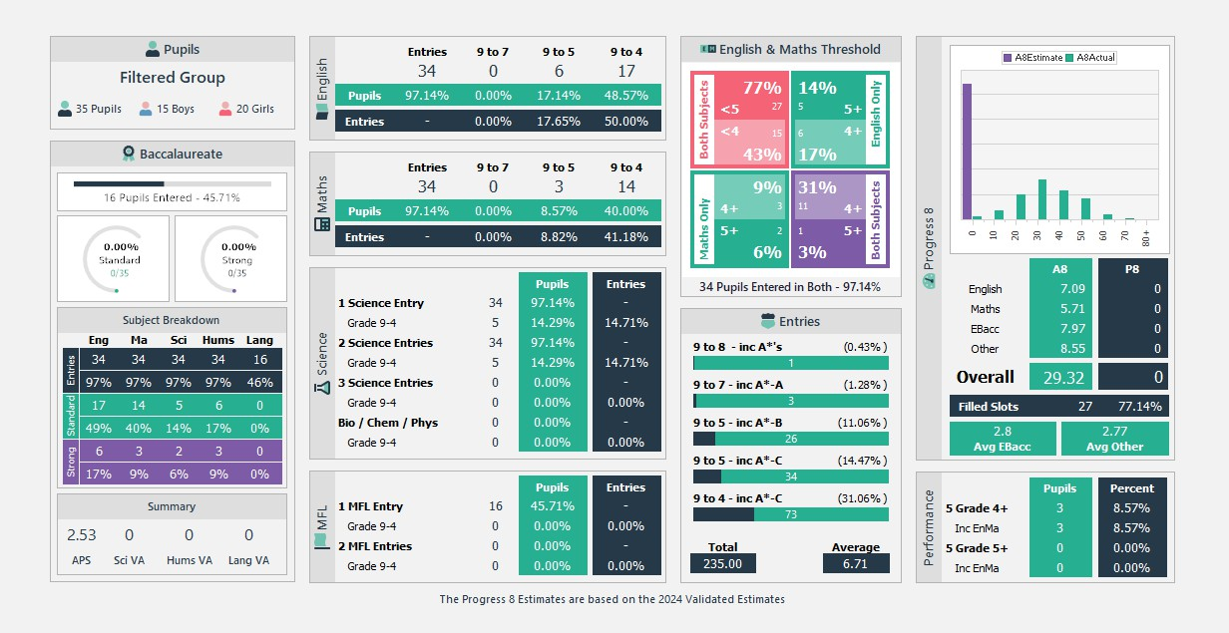

 |  | 2024/2025
Y11
Actual Exam Results PP Students
Title |  | # | %
Pupils
 | Students Included | 35
 | Boys Included | 15
 | Girls Included | 20
E&M Threshold
 | Only English 5 or Above | 5 | 14.29
 | Only Maths 5 or Above | 2 | 5.71
 | Both Subjects 5 or Above | 1 | 2.86
 | Only English 4 or Above | 6 | 17.14
 | Only Maths 4 or Above | 3 | 8.57
 | Both Subjects 4 or Above | 11 | 31.43
Attainment 8
 | Attainment 8 | 29.32
 | English Attainment 8 | 7.09
 | Maths Attainment 8 | 5.71
 | EBac Attainment 8 | 7.97
 | Other Attainment 8 | 8.55
Baccalaureate
 | English 5 or Above | 6 | 17.14
 | Maths 5 or Above | 3 | 8.57

 | Science 5 or Above | 2 | 5.71
 | Languages 5 or Above | 0 | 0
 | Humanities 5 or Above | 3 | 8.57
 | English 4 or Above | 17 | 48.57
 | Maths 4 or Above | 14 | 40
 | Science 4 or Above | 5 | 14.29
 | Humanities 4 or Above | 6 | 17.14
 | APS | 2.53
 | English Pillar APS | 3.54
 | Maths Pillar APS | 2.86
 | Science Pillar APS | 2.91
 | Humanities Pillar APS | 2.11
 | Languages Pillar APS | 0.86
Performance
 | Pupils with 5+ A*-C (4+) | 3 | 8.57
 | Pupils with 5+ A*-C (Inc Maths & English 4+) | 3 | 8.57
English
 | Pupils achieving 9 to 7 in English (% of Pupils) | 0 | 0
 | Pupils achieving 9 to 5 in English (% of Pupils) | 6 | 17.14
 | Pupils achieving 9 to 4 in English (% of Pupils) | 17 | 48.57
Maths
 | Pupils achieving 9 to 7 in Maths (% of Pupils) | 0 | 0
 | Pupils achieving 9 to 5 in Maths (% of Pupils) | 3 | 8.57
 | Pupils achieving 9 to 4 in Maths (% of Pupils) | 14 | 40

Science
 | Pupils achieving 1 or more Sciences Grade 4 And Above | 5 | 14.29
 | Pupils achieving 2 or more sciences Grade 4 And Above | 5 | 14.29
 | Pupils achieving Three Sciences Grade 4 And Above | 0 | 0
 | Pupils achieving Grade 4 And Above in Biology, Chemistry & Physics | 0 | 0
MFL
 | 1 MFL grade 4 And Above (% of Pupils) | 0 | 0
 | 2 MFL grades 4 And Above (% of Pupils) | 0 | 0

Narrowing the Gaps

Summary of Actions Enhancing Outcomes for Pupil Premium Students:

- Provision of revision material to students in need.
- Conducted learning walks to assess support for Pupil Premium students and evaluate the quality of first-wave teaching.
- Implemented an independent study programme during mentor time, allowing students to reflect on areas for improvement while utilising available resources.
- Introduced Saturday Support, offering bespoke sessions in English and Maths to Pupil Premium students, providing a quiet space for consolidating learning and receiving additional assistance with homework, queries, and exam techniques.

The study skills and study entertainment evenings focus on students identified as the most disadvantaged Pupil Premium recipients who were not engaging in extracurricular activities.

  - Conducted reward programme and assemblies for Year 10/11 students.
  - Conducted information evenings for students and parents, so all barriers could be addressed and all information for support could also be conveyed.
  - Classcharts rewards enhanced lesson engagement and reduced behavioural issues.

All targeted student participated in student voice with an assigned staff member, aimed at discussing positives, negatives, and potential barriers, fostering character development and constructive dialogue with teachers.

Saturday Provision

Additional provision has been established to support pupil premium students on Saturdays in English and Mathematics. A survey conducted among students and parents revealed that parents felt less confident in assisting with GCSE preparation.
The Saturday programme offers a secure environment for students to engage in English and Mathematics with appropriate support and guidance.
Participants reported increased confidence in approaching GCSE problems and appreciated the opportunity to work in a quiet space, which is often unavailable at home. In total, 59% of students who attended these sessions achieved a Grade 4+ in English and Mathematics.

Attainment for Mathematics and English

Attainment in English and Mathematics remains a priority. While not officially recognised, progression for Pupil Premium students reflected through termly assessments has consistently improved year on year as student numbers increase across year groups.

Financial support to ensure inclusion.

Aylesford School has provided financial support disadvantaged students both pre and post lockdown. A summary of support:
- Revision material purchased for those behind in English and Maths
- Educake and Mathswatch accounts purchased for all PP students in KS4
- Financial support for hard up families in the form of clothing, food parcels and ICT equipment
- Financial support for trips and external activities
- Small group targeted intervention with external tutors/teachers
- Saturday School for extra English and Maths support

Externally provided programmes
Please include the names of any non-DfE programmes that you purchased in the previous academic year. This will help the Department for Education identify which ones are popular in England

Programme | Provider
Reading recovery | myON
Reading recovery | Sparx
Reading recovery | STAR Reader
Phonics KS3 catch up | Forward with Phonics
Homework and Revision KS4 | Classcharts
 | Senecca
Numeracy catch up | Mathswatch and Numeracy Ninjas
PSRE catch up curriculum | Jigsaw Education – PSRE catch up curriculum
Mental health training | Aquarius Mental Health
catch up | Zig Zag Education

