Guide to using Show My Homework without a log in

Go to Aylesford School website page and click on the “homework” link at the top right hand side of the page as shown below. www.aylesford.kent.sch.uk
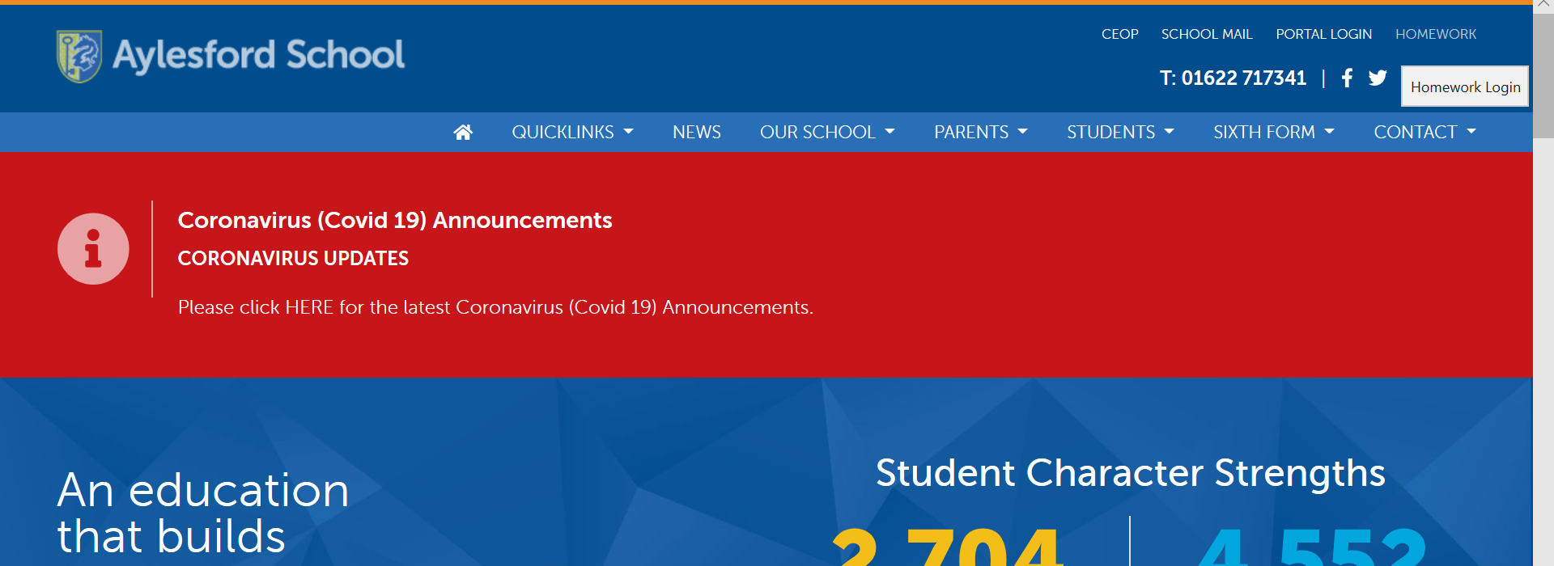
This will take you to the schools calendar page which will allow you to search by year group and subject to find the work which has been set.
Please note that not all work has been set by the class teacher so may appear under a different teacher’s name. Please search by subject and year group only – You will then be able to see your child’s class for that subject.
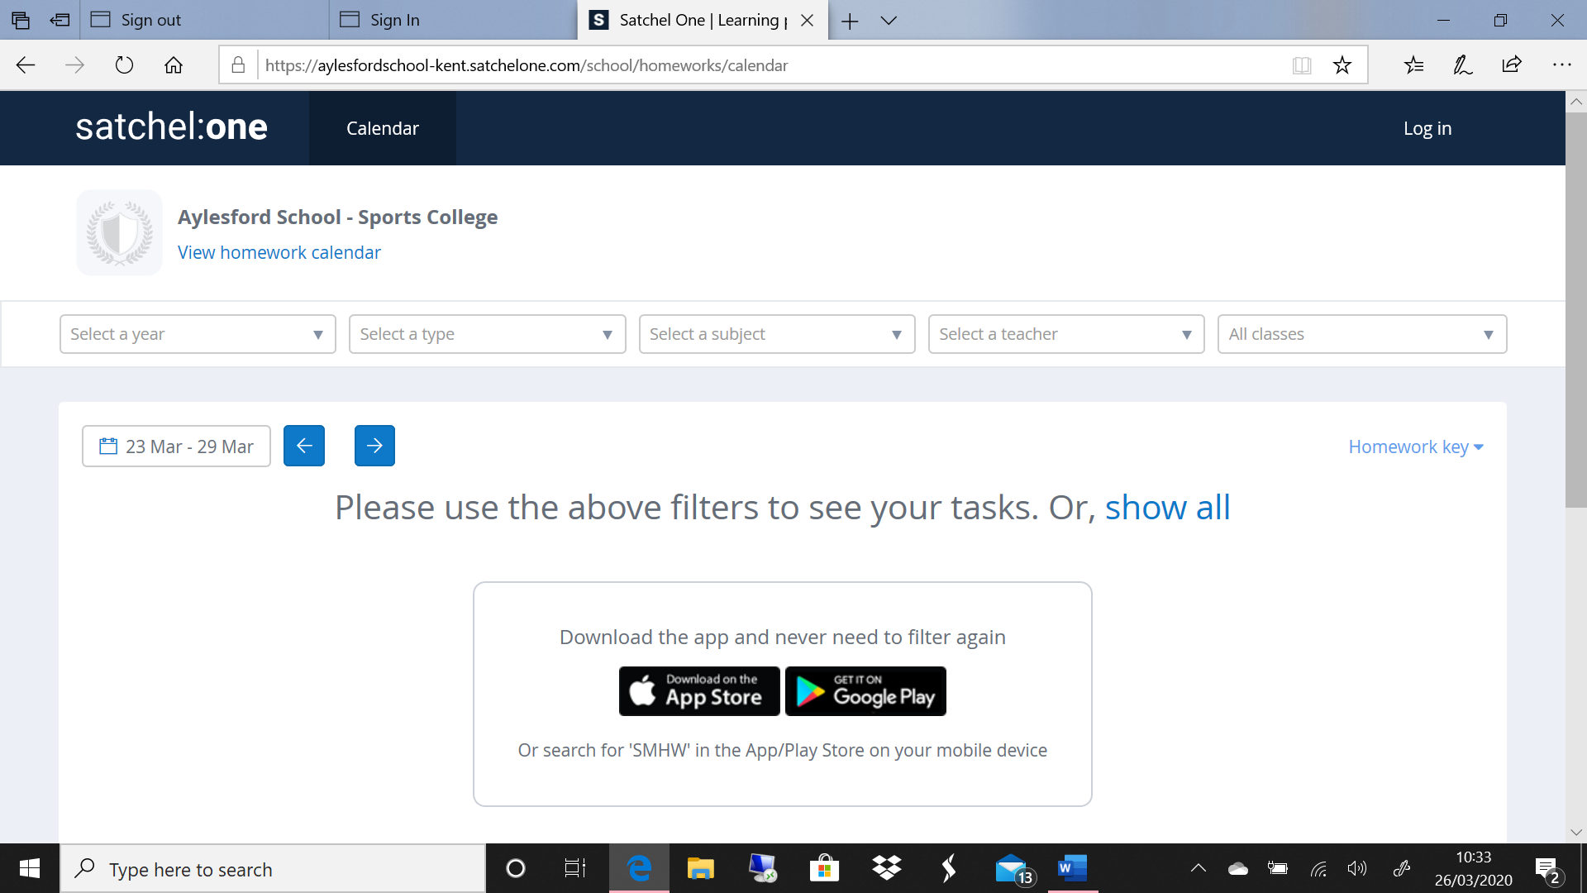

You can also go back to previous weeks to see work which was set or incomplete past homework. This can be done by simply clicking on the arrows back and forward

