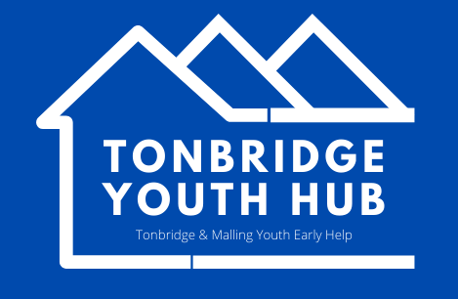
Tonbridge & Malling
Y2
Referral Form
Referrer Details:
Education placement

Support worker:
Named contact |  | Role
Contact Number(s) |  | Email

Young Person Details:
Young Person
DOB
Contact Number(s)
Email

Parental Details:
Parent / Guardian
Contact Number(s)
Email

Tick location:
Longmead 25/27/29 July
East Malling 1/3/5 Aug
Snodland 8/10/12 Aug

Information given below will help us to make sure we bring the right mix of young people together for the best experience for all

Any sensitive issues – for example any family issues, bereavement issues, learning difficulties?
Is there anything else we should be aware of? Friendship groups and dynamics? Concerns around social media usage?
Please list any agencies the young person is receiving support from and what that support currently looks like.

Family have completed open access membership form | Yes | No
Core+ Number (Admin only)

Please return referral form to Tonbridgeyouthhub@kent.gov.uk

