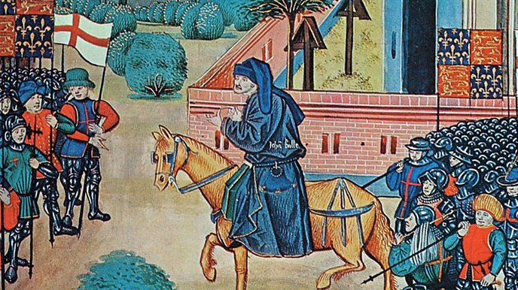
The Black Death and Peasant’s Revolt

Year 7 Homework Booklet Term 4
Name:
Tutor Group:
History Group:
Target Level:

Homework Task One – Keyword challenge
To be completed by:___________________
The reason we need to develop our understanding of historical keywords is that, in GCSE History, you will gain extra marks for using historical terminology.
Task:
- - You have one week to learn how to spell 15 of the following historical keywords.
- – You also have to research what each keyword means and write down the meaning, next to the keyword.
Number | Key Word | What does it mean?
1 | Pneumonic
2 | Bubonic
3 | Symptoms
4 | Feudal System
5 | Social
6 | Political
7 | Military
8 | Religious
9 | Economic
10 | Plague
11 | Peasants
12 | Revolt
13 | Statute of Labourers
14 | Poll Tax
15 | Serf

Homework Task Two – Black Death Source Activity
To be completed by:_________________
In History it is important to use evidence to understand key historical events.
Task:
- Read source A – Use source A to answer this question.
Q: Why did the Black Death spread so easily in 14th Century Britain? – Think about the conditions people were living in. Would this make it easy for a disease to spread?

Source A – www.historylearningsite.co.uk
“Towns were dirty places to live in. There was no sewage system as we would know it today. Many people threw toilet waste into the street along with other rubbish. Towns might use pigs to eat what rubbish there was. Water was far from clean as a local river would have been polluted with toilet waste thrown into it from villages both upstream and downstream. Therefore, as people would have used this as a source of water (they had no other choice) and because people knew little about health and hygiene, disease was common. Life expectancy could be short. Life for a poor person in a town or city was described as “nasty, brutal and short”.”

One way the Black Death spread so easily was ________________________________________________
This had an impact because____________________________
________________________________________________
Another reason the Black Death spread so easily was________
________________________________________________
This also had an impact because________________________
________________________________________________

- Read Source B – Use the source to draw and label the plague victim.
Key Word: Symptoms – the signs that you have a disease.
Source B - From an account written by Giovanni Boccaccio in Florence, Italy.

“Its earliest symptom was the appearance of fierce swellings in the groin or the armpit, some of which were egg-shaped whilst others were roughly the size of a common apple. People have called these swellings Buboes. By the second day, the victim would violently cough and vomit blood. The following day people have been known to find dark blotches and bruises under their skin, sometimes very large. If the victim was still alive, they could be seen shaking uncontrollably in their beds, screaming to God for relief. By the fifth day, God would finally show his mercy. The swellings might release a foul stench and dark liquid, which would sometimes mean the victim had been spared. But most times death would come swiftly, ending the endless pain and releasing his soul to God’s will.”
Challenge:
In your own words explain how the Black Death had an impact on people’s lives and their bodies.
________________________________________________
________________________________________________________________________________________________________________________________________________________________________________________________
________________________________________________

Homework Task Three – Black Death Cures Poster
To be completed by:________________
Task:
- Using the information about the Causes and Cures/ Prevention of the Black Death create a poster that could have informed people about the cures at the time that they may wish to try. Remember to include many pictures as not many people would read in those days!
Vinegar and Water Treatment | If a person gets the disease, they must be put to bed. They should be washed with vinegar and rose water
Lancing the buboes | The swellings associated with the Black Death should be cut open to allow the disease to leave the body. A mixture of tree resin, roots of white lilies and dried human excrement should be applied to the places where the body has been cut open.
Bleeding | The disease must be in the blood. The veins leading to the heart should be cut open. This will allow the disease to leave the body. An ointment made of clay and violets should be applied to the place where the cuts have been made.
Diet | We should not eat food that goes off easily and smells badly such as meat, cheese and fish. Instead we should eat bread, fruit and vegetables
Sanitation | The streets should be cleaned of all human and animal waste. It should be taken by a cart to a field outside of the village and burnt. All bodies should be buried in deep pits outside of the village and their clothes should also be burnt.
Pestilence medicine | Roast the shells of newly laid eggs. Ground the roasted shells into a powder. Chop up the leaves and petals of marigold flowers. Put the egg shells and marigolds into a pot of good ale. Add treacle and warm over a fire. The patient should drink this mixture every morning and night.
Witchcraft | Place a live hen next to the swelling to draw out the pestilence from the body. To aid recovery you should drink a glass of your own urine twice a day.

Homework Task Four – Peasants’ Revolt Creative Task
To be completed by____________

Task:
- Choose one of the creative tasks based on your own research and understanding of the Peasant’s Revolt:
Create a Peasant’s banner or poster with a slogan explaining a reason the peasants were protesting | Write a song that can be chanted during the protest. This should explain some of the causes.
Create a poem explaining what happened during the Peasants Revolt | Create a storyboard depicting the main events of the Peasant’s Revolt
Create a newspaper article explaining the impact of the Peasant’s Revolt | Write a Horrible Histories style sketch based on either the causes, main events or consequences of the Peasant’s Revolt
Homework task five – Quick Fire Quiz
To be completed by_____________
To make sure you are developing your knowledge and understanding in lessons, you will need to complete a quick fire quiz. This will be marked in the lesson.
Task: Multiple choice questions. Circle the correct answer for each question.
1 – What is another name for Black Death?  A – Bubonic Plague  B – Bubotic Plague  C – Bucolic Plague | 6-The Peasants’ Revolt took place in which year?  A – 1361  B – 1371  C – 1381
2-The plague originally spread from where?  A – Africa  B – Asia  C – South America | 7- Which law of 1351 made people angry?  A – The Edict of Peasants  B – The Law of Landowners’ Rights  C – The Statute of Labourers
3-The Plague was spread by fleas. What creature carried them?  A – Black rats  B – Harvest mice  C – Stray cats | 8 – Who was the main leader of the Peasants’ Revolt  A – Sam Tyler  B – Wat Tyler  C – Tom Tyler
4-What percentage of Britain’s population is thought to have died from the plague?  A – 10-25%  B – 33-50%  C- 70-80% | 9-Who was King of England at the time of the Revolt?  A – Richard II  B – Henry IV  C – Edward II
5 – Things were made worse by the pneumonic plague that attacked what?  A – Bone marrow  B – The kidneys  C – The lungs | 10-Who led the peasants alongside Wat Tyler?  A – Land Tax  B – Poll Tax  C – Window Tax
Challenge: Explain some reasons why the Black Death and the Peasants’ Revolt have become significant events in history
_______________________________________________________________________________________________________________________________________________________________________________________________________________

