Thursday 9th May 2019

Dear Parent/Carer,

Re: Year 8 Parents Evening

Following the recent letter sent out regarding a Year 8 parents evening on Thursday 23rd May and parental response, we have decided to cancel the year 8 parents evening in light of the further curriculum evening on Thursday 20th June, in a view to reduce the workload and time spent coming into school.

Students will receive their term 5 reports on Thursday 23rd May and following this, if you wish to make appointments to see teachers please do so by contacting Miss Kelvie or Mr Cooper directly. Below is a list of the key dates in the run up to your son/daughter’s curriculum choices being confirmed.

Key Dates:

Friday 14th June 2019 - Students should read the provided subject information carefully and attend the Curriculum Evening.
Thursday 20th June 2019 at 5:30pm – Curriculum Evening.
Monday 24th June 2019 - The curriculum form which will be included in the information book you receive at the curriculum evening will need to be filled in carefully and returned to mentors.
Monday 1st July 2019 - Students will have an interview with a member of senior staff to discuss their choices in the week beginning.
Monday 15th July 2019 - Students will be informed of their confirmed curriculum.

Thank you for your continued support.

Yours sincerely,
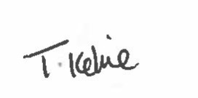
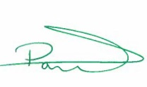

Miss T Kelvie Mr P Cooper
Headteacher Year 8 Progress Leader

