Superpower relations and the Cold War 1941-91
Homework Booklet 1
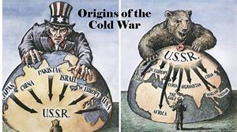

Name:
Tutor Group:
History Group:
Target Level:

Homework Task One – Keyword challenge
To be completed by:___________________
The reason we need to develop our understanding of historical keywords is that, in GCSE History, you will gain extra marks for using historical terminology.
Task:
- - You have one week to learn how to spell 15 of the following historical keywords.
- – You also have to research what each keyword means and write down the meaning, next to the keyword.
Number | Key Word | What does it mean?
1 | Soviet Union (USSR)
2 | Communism
3 | Capitalism
4 | Ideology
5 | The Grand Alliance
6 | Democracy
7 | Satellite State
8 | Reparations
9 | Atomic Bomb
10 | Telegram
11 | Iron Curtain
12 | Truman Doctrine
13 | Containment
14 | Isolationism
15 | Dollar Imperialism

Homework Task Two – Who are you?
To be completed by:_________________
In History it is important to understand the key people involved in events/actions. In Superpower relations and the Cold War there were several key people involved.
Task:
- Your homework is to investigate and write down key facts about each key person to support your knowledge and understanding of the key topic. Two pages to complete.
- Things to include: Which country were they linked to? When? How were they involved in the Cold War? Any key events linked to the Cold War that occurred during their time in power? Bullet point your research.
Franklin D. Roosevelt | Winston Churchill | Joseph Stalin
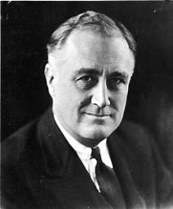 | 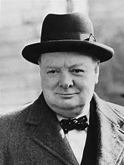 | 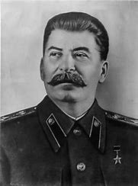
Harry S. Truman | Clement Attlee | George Kennan
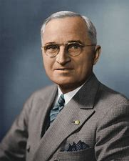 | 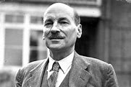 | 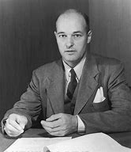
Nikolai Novikov | Dwight Eisenhower | Nikita Khrushchev
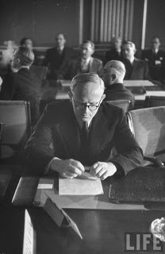 | 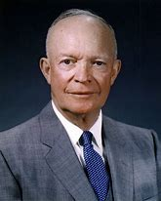 | 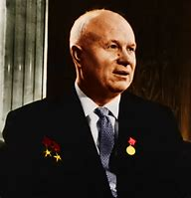
Imre Nagy | John F. Kennedy | Fidel Castro
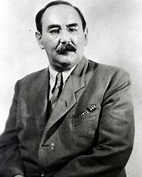 | 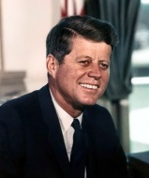 | 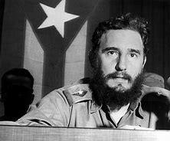
Alexander Dubcek | Leonid Brezhnev | Richard Nixon
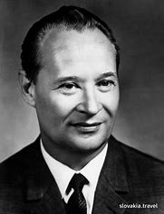 | 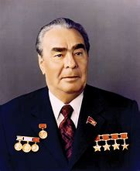 | 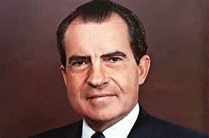
Jimmy Carter | Hafizullah Amin | Ronald Reagan
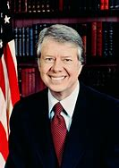 | 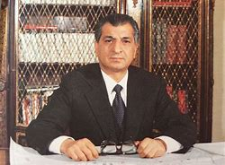 | 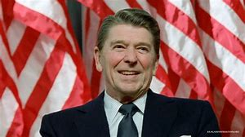
Mikhail Gorbachev | Boris Yeltsin
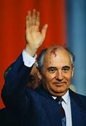 | 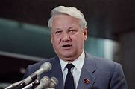

Challenge: Which person do you think had the biggest impact (positive or negative) on the Cold War and why?
______________________________________________________________________________________________________________________________________________________________________________________________________________________________________________________________________________________________________________________________________________________________________________________________________________________________________________________________________________
Homework Task Three – Narrative GCSE question
To be completed by:________________
Task:
Write a narrative analysing the key events of the Soviet takeover of the satellite states in the period 1944-48. 8 marks.
You may use:
- Warsaw Uprising
- Communist takeover of Czechoslovakia
Chronology of events | Key facts to state what happened
What caused the Soviet takeover of the satellite states?
Use first bullet point to help
State events of the Soviet takeover of the satellite states.
Include events of your own knowledge.
Explain the consequences of the Soviet takeover of the satellite states on the Cold War.

Homework Task Four – Importance question
To be completed by____________
Task:
Explain two of the following: 16 marks
- The importance of the Truman Doctrine for the development of the Cold War I the years 1947-55.
- The importance of the Berlin Blockade for the future of Germany.
- The importance of the formation of NATO for relations between the USA and the Soviet Union.
_____________________________________________________________________________________________________________________________________________________________________________________________________________________________________________________________________________________________________________________________________________________________________________________________________________________________________________________________________________________________________________________________________________________________________________________________________________________________________________________________________________________________________________________________________________________________________________________________________________________________________________________________________________________________________________________________________________________________________________________________________________________________________________________________________________________________________________________________________________________________________________________________________________________________________________________________________________________________________________________________________________________________________________________________________________________________________________________________________________________________________________________________________________________________________________________________________________________________________________________________________________________________________________________________________________________________________________________________________________________________________________________________________________________________________________________________________________________________________________________________________________________________________________________________________________________________________________________________________________________________________________________________________________________________________________________________________________________________________________________________________________________________________________________________________________________________________________________________________________________________________________________________________________________________________________________________________________________________________________________________________________________________________________________________________________________________________________________________________________________________________________________________________________________________________________________________________________________________________________________________________________________________________________________________________________________________________________________________________________________________________________________________________________________________________________________________________________________________________________________________________________________________________________
Homework task five – Quick Fire Quiz
To be completed by_____________
To make sure you are developing your knowledge and understanding in lessons, you will need to complete a quick fire quiz. This will be marked in the lesson.
Task: Multiple choice questions. Circle the correct answer for each question.
1 – What was the name of the first conference in 1943?  A – Potsdam  B – Tehran  C – Yalta | 6-What was the official military name of the Berlin Airlift?  A – Operation Vittles  B – Operation Sealion  C – Operation Airlift
2-Which country dropped the Atomic bombs on Japan in 1945?  A – USA  B – USSR  C – Germany | 7- What was the official name given to East Germany?  A – Federal Republic of Germany  B – German Democratic Republic  C – Federal Democratic of Germany
3-Which European country became a satellite state in 1948?  A - France  B – Poland  C – Czechoslovakia | 8 – What weapon did the USA successfully test in 1952?  A – Atomic Bomb  B - ICBM  C – Hydrogen Bomb
4-What did the Marshall Plan provide to prevent the spread of communism?  A – Military aid  B – Money  C- Food | 9-Which leader of the USSR was in charge during the Hungarian Uprising?  A - Khrushchev  B - Stalin  C - Brezhnev
5 – Which countries were part of Trizonia?  A – USA, Italy, France  B – USSR, USA, Britain,  C – France, USA, Britain | 10-Who was the President of the USA when the Berlin Wall was built?  A – Franklin Roosevelt  B – John F. Kennedy  C – Dwight Eisenhower

Challenge: Who led the Cuban revolution in 1959? Why did they want to take over Cuba?

Homework Task Six – Revision
To be completed by______________
Your task: Revision of what you have learnt so far.
This should include:
- The Grand Alliance
- The 3 conferences
- The creation of the Satellite States
- The Telegrams
- Truman Doctrine and Marshall Plan and the USSR response.
- The Berlin Crisis
- NATO and Warsaw Pact
- Arms Race
- Hungarian Uprising 1956
- Berlin Wall
- Cuban Revolution
- Bay of Pigs
- Cuban Missile Crisis

Key skills:
Question 1 – Explain two consequences – 8 marks
Question 2 – Write a narrative – 8 marks
Question 3 – Explain two ‘importance of’ – 16 marks

